Science: Life cycles
Us this website to research life cycles, watch the video’s and get creative with making a life cycle. Write a small paragraph explain what each stage is and what is happening.
What is a life cycle? | TheSchoolRun
DT: Make a biome in a bag
Make a rainforest in a bag! Attached are instructions on how to make a biome in a bag! It tells you what you need and everything that you need.

Hi Hawthorn Class!
Here is your homework for this term. You can be as creative as you like. If you need some resources, which we might have in school, please come and ask me — I will do my best to help out!

Homework is due in on Monday 5th February 2022
Have fun!

Art: Create a drawing of a Biome.
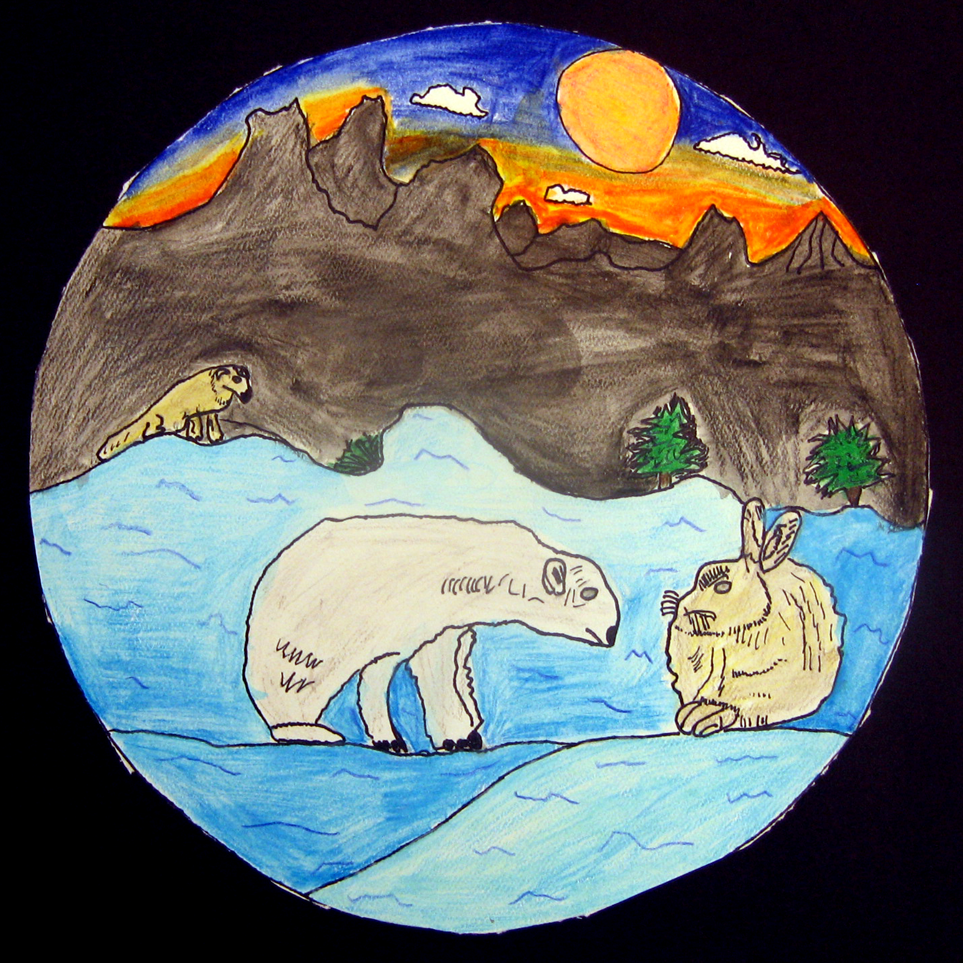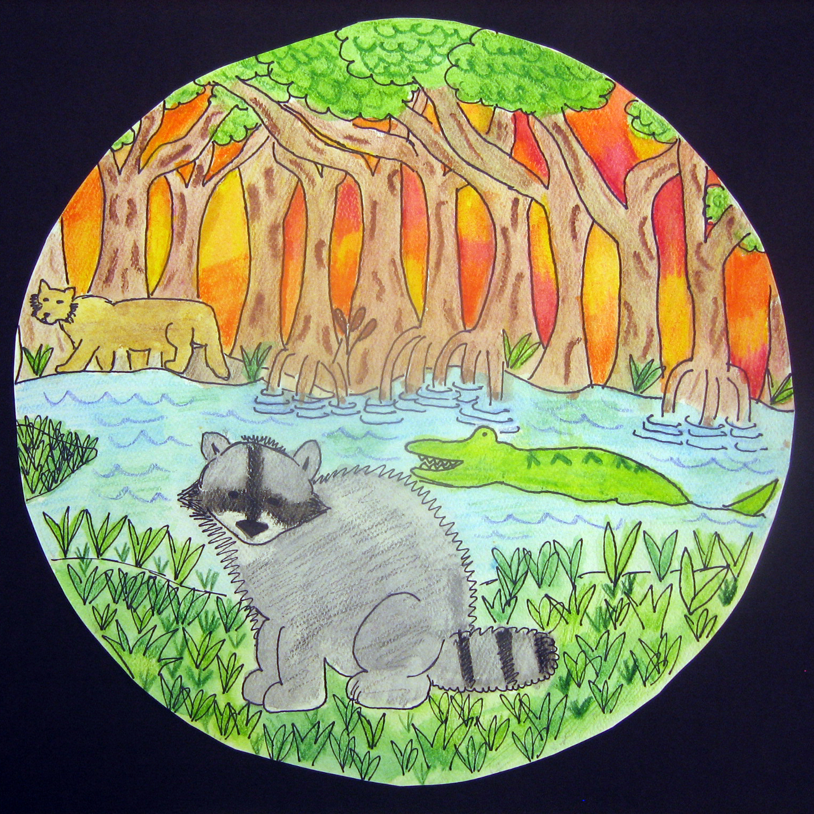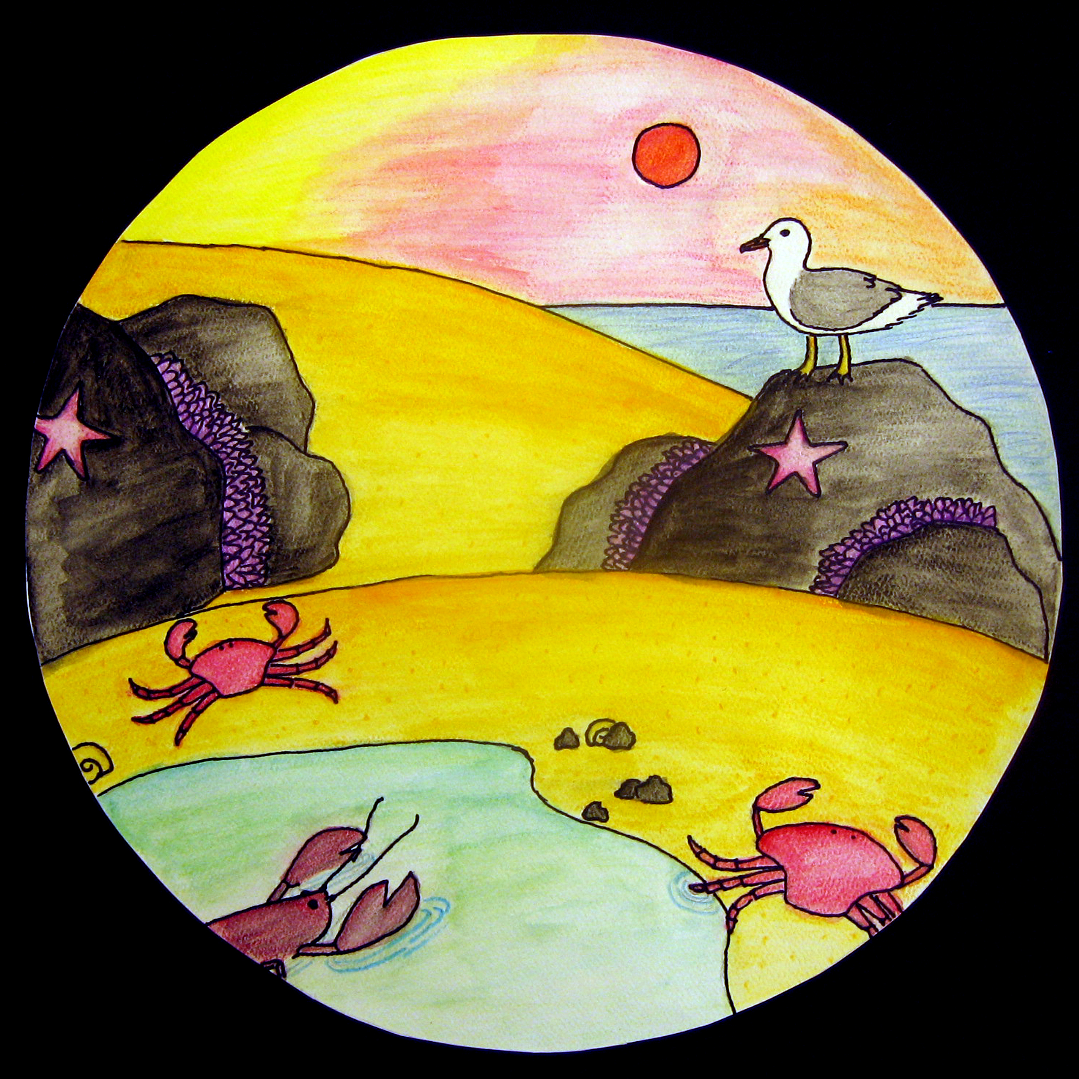
Create a Biome scene like the ones above. You can choose which place you would like to draw. Somewhere hot? Somewhere cold? Use this website for ideas:
Biome Illustrations | Ms. Amsler's Artroom (amslerartroom.com)

English: Create a fact file
Choose a biome and create a fact file about all the types of plants and animals found in that biome.

Use this website to help you:
The Five Major Types of Biomes | National Geographic Society

Geography: Compare Biomes around the world.
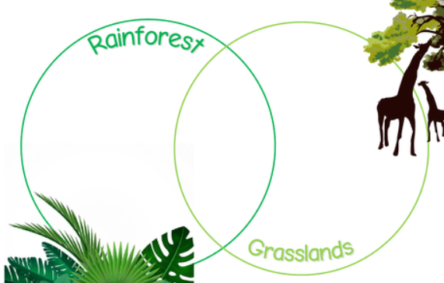

Pick a few locations and compare them. What is the same and what is different?
Use this website to help you:
Science for Kids: World Biomes and Ecosystems (ducksters.com)


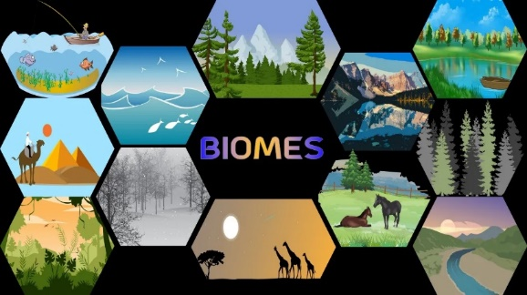

Creative Homework
Spring Term 1
Hawthorn class — Year 5

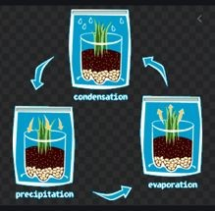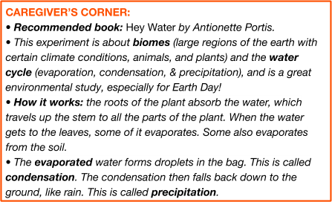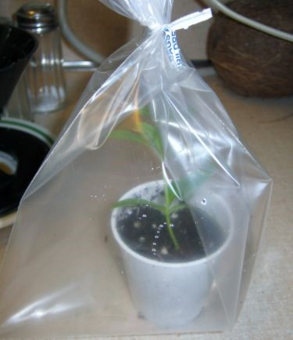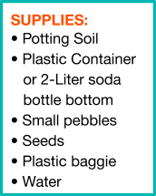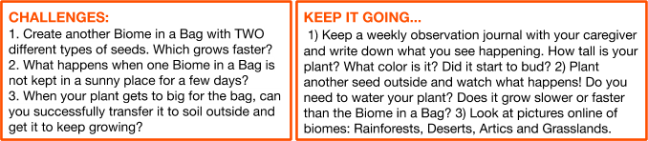
WCM at Home
​
from the Westchester Children’s Museum

ome
B
i
i
n a Ba
g

C
r
e
a
t
e

y
o
u
r

o
w
n

R
a
i
n
f
o
r
e
s
t

Have you ever wanted to walk through a real rainforest and

observe all of the beautiful plants that grow?
​
We’ve got the

second best thing: you can create your own rainforest biome in

a bag! Do you have plants or a garden at home? Do you help

water plants in your home? Well, you won’t need to water these

seeds again, because the water will recycle itself. How do you

think this will happen?

1.
Pour pebbles into the bottom half of the plastic container. They

should be about a half an inch deep.

2.
Pour some potting soil over the pebbles. It should have about

twice as much soil as pebbles.

3.
Make a small trench down the center of the soil.

4.
Sprinkle some seeds in the trench and then fill it up with soil.

5.
Water the soil just until you see the water collect at the bottom

of the pebbles.

6.
Put the biome in a plastic baggie and seal it up.

7.
Place in a sunny place and in 3-4 days watch it grow!

