Science:
Find out more about the construction of the pyramids. Which materials would be best for pyramid building?

Why don’t you draw a diagram of what a pyramid would look like and where the different materials are used?
Introduction - The Children's University of Manchester
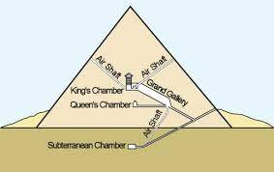
Art:
Design your own hieroglyphic alphabet using pictures relevant to life in Britain today.
Egyptian Hieroglyphic Alphabet (discoveringegypt.com)
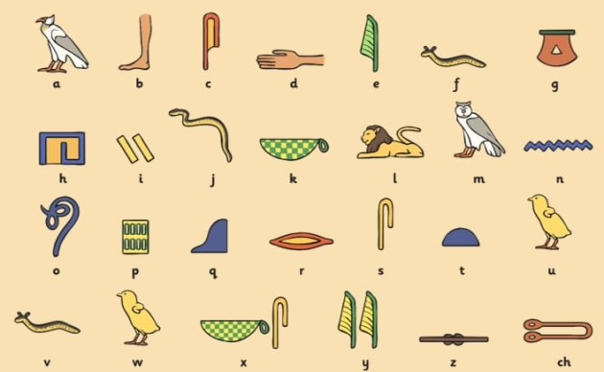
Hi Hawthorn Class!
Here is your homework for this term. You can be as creative as you like. If you need some resources, which we might have in school, please come and ask me — I will do my best to help out!

Homework is due in on Monday 25th March 2024
Have fun!

DT:
After mummification, people were buried in a tomb wearing a death mask.
Design a death mask for Tutankhamun.
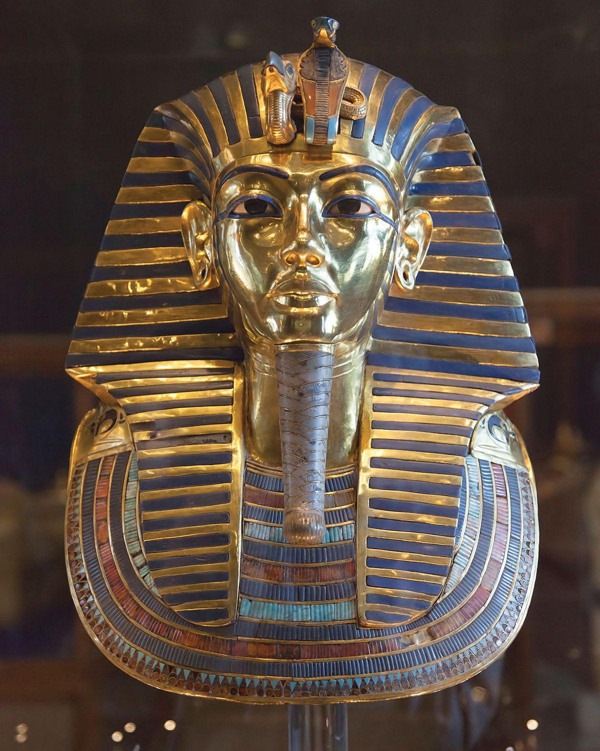
Ancient Egyptian death mask - Young Archaeologists' Club - Archaeology for you (yac-uk.org)

English:
Create a fact-file on a famous Ancient Egyptian, for example Tutankhamun or Nefertiti.

Tutankhamun facts! | National Geographic Kids (natgeokids.com)
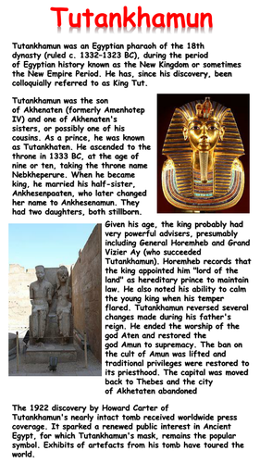

Geography:

Create a map showing the key places in Ancient Egypt. How has the country changed?

Ancient Egypt Map - Illustrative overview map highlighting the main sites and settlements of the Ancient Egyptian civilisation | Merritt Cartographic

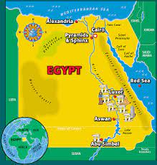

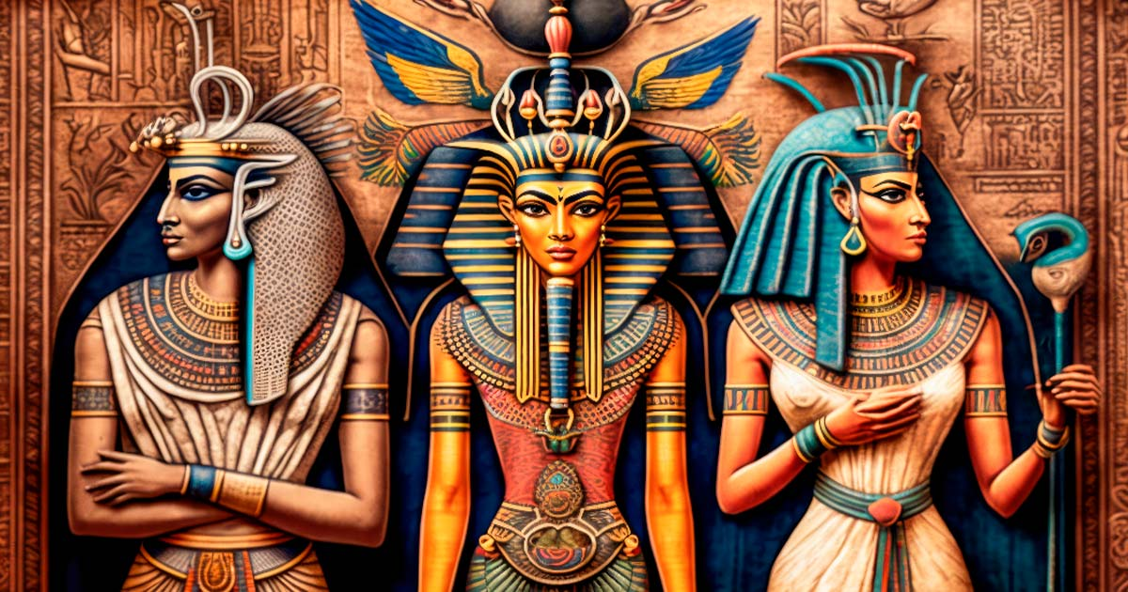
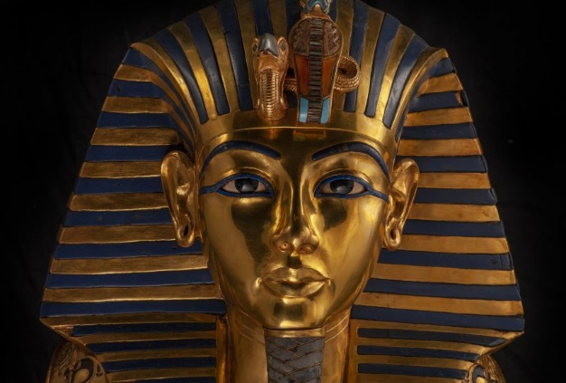

Creative Homework
Spring Term 2
Hawthorn class — Year 5

