History: Police uniforms.

Use images or drawings to show how police officers’ uniforms have changed over the years.

Police Uniform and Equipment | Gloucestershire Police Archives
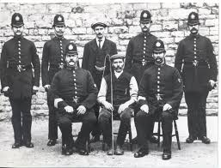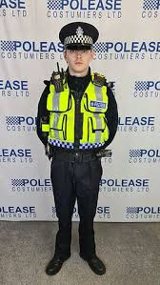
Art: Create a wanted poster.
Create a wanted poster for a famous, real or fictional person. Don’t forget to include their crimes and a reward
You can either make this on paper or use the website below to create your own wild west style poster.

https://www.tuxpi.com/photo-effects/wanted-poster

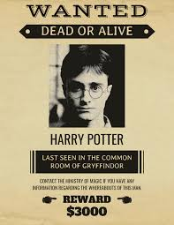
Hi Hawthorn Class!
Here is your homework for this term. You can be as creative as you like. If you need some resources, which we might have in school, please come and ask me — I will do my best to help out!

Homework is due in on Monday 15th July 2024
Have fun!

English: Write your own laws!
Imagine you are in charge of the country and write a set of laws.
Remember to include what the punishments would be for breaking the laws.
Law Facts for Kids (kiddle.co)
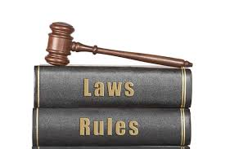

History: Timelines

Can you create a timeline of punishments throughout the ages. Use your knowledge of timelines to show when certain punishments happened.

https://www.bbc.co.uk/bitesize/topics/z8w3n9q
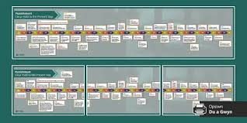

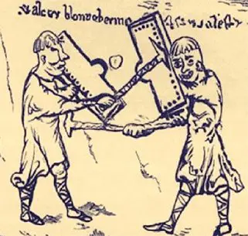
Creative Homework
Summer Term 2
Hawthorn class — Year 5

