Creative Homework
Autumn Term 1
Oak class — Year 6
Civil Rights 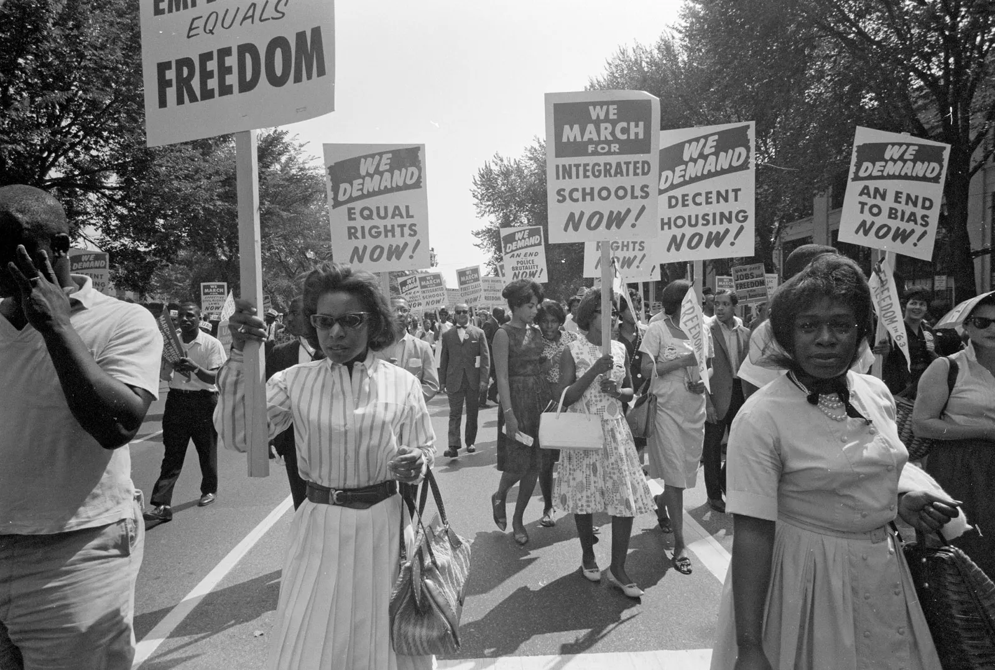
Create a poster
Create a poster about Rosa Parks and what she did for civil rights.
Describe how she went against discrimination and stood up for her rights.
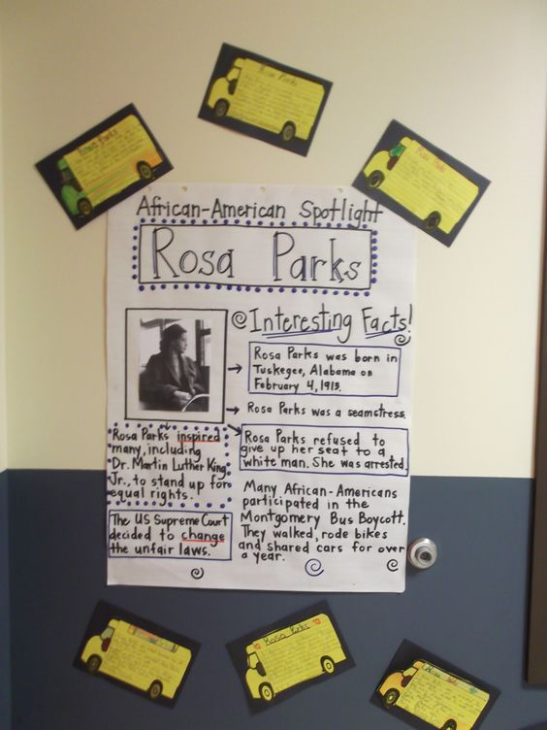
https://www.natgeokids.com/uk/discover/history/general-history/rosa-parks/
Write your own laws
Imagine you are in charge of the country and write a set of laws that give everyone in our country the rights they deserve.

https://www.history.com/news/civil-rights-legislation

Hi Oak Class!
Here is your homework for this term. You can be as creative as you like. If you need some resources, which we might have in school, please come and ask me — I will do my best to help out!
Homework is due in on Monday 14th October 2024
Have fun!

What are human rights?
Research what human rights are or watch the videos linked and write a description of human rights in your own words. Draw pictures to go with your writing.

https://www.bbc.co.uk/bitesize/topics/zyg2xbk/articles/zqgm7yc
https://www.bbc.co.uk/bitesize/topics/zgd88hv/articles/zg7rcmn
Timeline
Create a timeline of the civil rights movement.
Use your knowledge of timelines to show when certain events happened.
https://www.history.com/topics/black-history/civil-rights-movement-timeline


